# **Letters: Anatomy & Importance in Graphic Design**

## **What Is Letter Anatomy?**

**Letter anatomy** is a set of vocabulary terms used to describe the construction of letters in graphic design. While most people who look at [typography](https://study.com/learn/lesson/typography-history-terminology-examples.html) simply see letters and words, [graphic designers](https://study.com/learn/lesson/what-is-graphic-design.html) actually have an extensive set of terms to describe the different parts and qualities of different letters. These terms can help typographers who are designing new typefaces and can also allow for precision when discussing or creating lettering. Each letter is made up of different elements that can be combined in different ways to produce a wide variety of effects.

## **Categories of Graphic Letters**

There are several different categories used to describe graphic letters. Typographers are typically familiar with all of these categories, though they may specialize in certain areas of letter development over others. Letters can be described in terms of their anatomy, meaning the specific parts of each letter. They can also be described in terms of size and scale or in terms of letter families. Letter families are types of letters that share one or more noteworthy characteristics. They are not the same thing as typefaces, though a thorough understanding of different typefaces is also essential for typographers and graphic designers.

### **Anatomy**

In common parlance, ''anatomy'' is a term that refers to the bodies of living organisms. However, in typography, it refers to the different parts of each letter. Some terms apply to all letters and some to only certain letters. Important terms and their meanings include:

| **Anatomy Term** | **Explanation** |
| --- | --- |
| Stem | The stem of a letter is its main vertical element from which other elements might branch off. The letter K is a great example of a letter with a stem; B, P, D, F, and E also have stems. |
| Stroke | A stroke is similar to a stem, but it is diagonal instead of vertical. The primary diagonal line in any letter is the stroke. Z is the letter with the most obvious stroke, but W and A also have strokes. |
| Bowl | A bowl is a curved line of a letter that encloses a space. The curves of B, D, and O are all bowls. |
| Counter | The enclosed space that a bowl creates is called a counter. O and Q are examples of letters with a counter. Counters are sometimes called eyes, especially when the enclosed space is smaller, as in a lower-case e or a. |
| Bar | Also called a crossbar, a bar is a horizontal line across a letter. A, H, and T all feature a bar. |
| **Serif** | A serif is a short horizontal line at the end of each line of a letter. Not all typefaces include serifs; type can be serif or sans-serif. |
| **Terminal** | In sans-serif typefaces, a terminal is the end of any line in a letter. The shape of a terminal varies by typeface, but can be sharp, square, rounded, teardrop-shaped, or circular. |
| Arm | An arm is a part of a letter that extends horizontally or diagonally upward from the stem or stroke. An E has three arms, while an L has one. A K has an arm that points diagonally up. |
| Leg | Short diagonal strokes that extend from a letter are called legs. The diagonal stroke on an R is a good example or the lower diagonal on a K. |
| Spine | The only letter with a spine is an S, both upper- and lower-case. The spine is the primary curve of the letter because it echoes, to some extent, the shape of a human spine. |
| Shoulder | The shoulder of a letter is a curved line branching off from the stem. Shoulders can be found on the letters h, n, and m. |
| Ear | On a lower-case g, in some typefaces, there is a small stroke at the top right of the letter that is called an ear. No other letter typically has this feature. |
| Swash | A swash is not an essential element of any letter, but rather a decorative addition found in some typefaces. It is a curving or calligraphic twist on a letter's serif or terminal often found on signage or wedding invitations. |
| Loop | Like a bowl or eye, a loop is an enclosed space in a letter. It is distinct from other enclosed spaces because it is at the bottom of the letter, below the baseline. A lowercase g in some typefaces has a loop. |
| Link | A link is part of a letter that connects two other elements. On a lower-case g in some typefaces, a link connects the top bowl and the bottom loop. |

Many of these terms come from human anatomy and the specific elements in any given typeface can vary greatly.

### **Size and Scale**

Another important way of describing letters is in terms of their size and scale. Letters are usually described in relation to their **baseline**, which is the horizontal line that all letters rest on, just like on a piece of lined paper. Letters are sometimes described in terms of **x-height**, which is the distance from the baseline to the **median**, or the height occupied by a lower-case x. The median is the point at which most letters end above a baseline. Letters like w, e, u, o, a, s, z, and x are all x-height. Capital letters, on the other hand, are what is known as **cap height**, the distance from the baseline to the top of a capital letter.

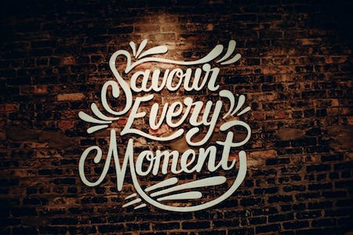

***This sign makes use of swashes and other decorative elements***

Some letters break out of this mold by using **ascenders** and **descenders**. Ascenders rise above the median line and descenders fall below the baseline. Letters like t, l, k, and h have ascenders, while q, p, and y have descenders. The scale of a typeface can be both horizontal and vertical. This is the measure of the typeface's size compared to any other elements in an image or on a page. The point size of a typeface is the standard way to describe scale; most books, papers, and other long-form text elements are written in twelve-point type. The distance between the letters is called kerning, which is something that typographers have to pay close attention to in order to ensure good readability.

### **Letter Families**

Letter families are specific kinds of typeface modifications that share certain characteristics. The most common letter family or typeface style is called roman; plain text in any regular typeface is roman text. When a roman typeface is slanted, the writing is in *italics*. Likewise, a heavier style of typeface is called **bold**. As previously mentioned, typefaces can be either serif or sans-serif. There are various benefits and drawbacks to both styles. A final kind of letter family is the case system. Letters can be upper-case, meaning CAPITAL LETTERS, or lower-case, meaning smaller letters. They can also be small caps, which are capital letters that are x-height instead of cap height.

## **Examples of Graphic Letters**

Graphic letters can look very different and can convey particular emotions or ideas depending on the typographic elements in play. For instance, the following text uses a serif font with no capital letters. Most letters are x-height, but the d is an ascender and the y is a descender. The n and m are good examples of shoulders.

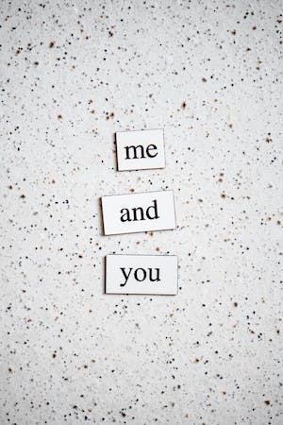

***This typography uses a serif font and no capital letters***

In the following contrasting example, all of the letters are upper-case. There are no serifs and the terminals are squared off. The letters provide examples of stems, strokes, arms, legs, bars, bowls, and counters.



***This text is sans-serif and is in all capital letters***

Even in these brief examples, the mood and feeling of each piece of text differ based on the typographic characteristics present or absent.

## **Significance of Letters in Graphic Design**

Understanding how graphic design letters go together and which elements form them is an important skill that is often overlooked. Graphic designers use their understanding of letter anatomy to determine which typefaces look good together, ultimately creating the visual environment of the vast quantities of written information that many people engage with on a daily basis online and offline. Letter anatomy knowledge can also aid in accessibility efforts, ensuring that typefaces and special characters will be compatible with computer software, fixing kerning errors, and making a number of aesthetic decisions to create the proper design and flow for a website, book, or document.